Form 106 Issue 5
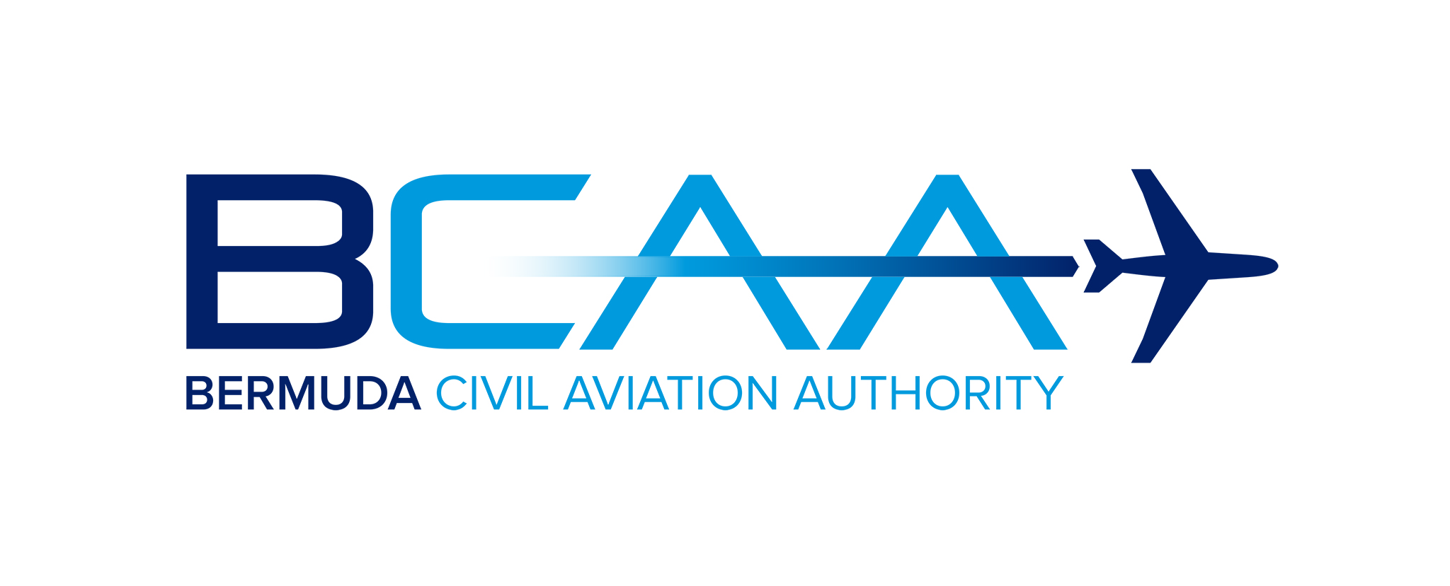
Checklist for Registering Aircraft
Under Article 83 bis Agreement

To assist you through the process of placing an aircraft operated under an ICAO Article 83bis agreement on the Bermuda Register, please find below details of the requirements for aircraft registration and initial issue of a Certificate of Airworthiness approvals.

1. To enable the registration processes to begin, submit completed signed copy of the Application for Registration of Aircraft or Change of Ownership (Form 100(B)) with applicable documentation. A representative from the registered owner or operator should be nominated to be the main point of contact with the registry throughout the process. The form will be reviewed by the Bermuda Civil Aviation Authority (BCAA) within a few days and it will be confirmed that the aircraft is eligible and the owner qualified for the aircraft to be registered in Bermuda.

2. Subsequently, steps 2 through to 9 can be completed as part of the registration process to permit BCAA to issue the Certificate of Registration.

3. The steps to be completed prior to issuance of a Certificate of Airworthiness are outlined in steps 10 through to 19 and this process can commence once the applicant has received the confirmation outlined in 1. above. A Nominated Airworthiness Technical Coordinator should be made available to enable the applicant to provide the related airworthiness coordination and documentation.

4. Processes outlined in 2., 3., above will run concurrently. Please submit all applications electronically. A summary of each step of the process follows as well as a link to the appropriate form if applicable.

5. The Air Navigation (Overseas Territory) Order 2013 (AN(OT)O) has been promulgated and sets out the provisions to enable Bermuda (United Kingdom) to comply with the ICAO Convention and in particular the Annexes to that Convention in the OTs. The OTARs are the Overseas Territories Aviation Requirements and these provide the means of compliance with the rules and regulations in the AN(OT)O. The applicable OTARS are included in the checklist as applicable.

Checklist

BCAA Initial Application Stage
1 |  | Application for Registration of Aircraft or Change of Ownership (Form 100B)  Once the Form 100B has been completed, BCAA will be able to confirm to the applicant that the aircraft is eligible and the person or corporation qualified to have an aircraft registered in Bermuda. If an applicant would require special marks they should make the request when submitting the Form 100B.
Prior to Issue of a Certificate of Registration – Reference OTAR 47
2 |  | Power of Attorney (if applicable)  Required if a person or persons will be signing applications on behalf of the registered owner of the aircraft.
3 |  | Affidavit or Certified True Copies of the Bill of Sale (Proof of Ownership) AND/OR Lease Agreement where the registered owner is a Charterer by Demise.
4 |  | Certified True Copies of the Certificate of Incorporation and List of Company Directors.
5 |  | Priority Mortgage (if applicable)  Once accepted the Priority Notice is valid for fourteen working days. To maintain priority, the contemplated mortgage must be made and entered in the Mortgage Register or further Priority Notice entered within the fourteen day period.
6 |  | Deregistration Notice OR Certificate of Non-Registration document received from the previous State of Registry.
7 |  | Certificate of Registration is issued
8 |  | Registration of Mortgage (if required)  Once the Mortgage document is received by BCAA an entry will be made on the appropriate Aircraft or Engine Mortgage Register.
9 |  | Registration of an Irrevocable De-registration and Export Request Authorisation” (IDERA) (if required)  Information concerning establishment of an IDERA can be found on the BCAA website - https://www.bcaa.bm/guidance-application-cape-town-convention-bermuda.
Airworthiness Applications and Required Documents – Reference OTAR 21, 36, 39, 43
10 |  | Application for the Issue of a Certificate of Airworthiness Form AW-200
11 |  | Arrangements for Continued Airworthiness Management  The holder of an air operator's certificate or the owner or operator of an aircraft above 2,700 kg MTOW must have arrangements for continued airworthiness management. The Continued Airworthiness Management Organisation (CAMO) must be BCAA approved under the requirements of OTAR 39 Subpart E. The operator may seek approval themselves or contract a separate CAMO. The operator should make arrangements for the management of their aircraft in the early stages of the registration process and inform the BCAA of those arrangements.
12 |  | Recommendation for the Initial Issue of a Certificate of Airworthiness Form AW-201(I)  This form is to be completed and submitted by the Operator's Continued Airworthiness Management Organisation (CAMO) along with the required supporting documentation.
13 |  | Maintenance Programme  All aircraft on the Bermuda register must be maintained in accordance with a BCAA approved maintenance programme. To apply for approval the applicant should submit a copy of the maintenance programme along with the Aircraft Maintenance Programme Approval Application Form AW-285 and OTAR 39 Maintenance Programme Compliance Checklist Form AW-287.
14 |  | Export Certificate of Airworthiness  The applicant should provide a copy of the Export Certificate of Airworthiness issued by the last state of registry. The Export Certificate of Airworthiness must be issued within 60 days of the Certificate of Airworthiness application.
15 |  | Application for a Noise Certificate Form AW-268
16 |  | Declaration of Flight Manual Supplements Form AW-235
17 |  | Nationality and Registration Markings  The aircraft must display Nationality and Registration markings on the lower left hand wing and on both sides of the fuselage or on the upper halves of the vertical tail. The Aircraft Marking requirements are found in OTAR Part 47.
18 |  | ELT Registration  View the latest AW Notices for 83bis Operators – AW-01-20. Bermuda will no longer be issuing ELT Codes (406MHz).
19 |  | Mode S Transponder  The Mode S code will be provided by BCAA and the transponder must be programmed with this code.
20 |  | Class Six Radio License  The applicant will normally apply to the Bermuda Regulatory Authority for a Class Six Radio License (https://www.ra.bm/electronic-communications-licences-radio-licences/). Note: Some Agreements transfer the issuance of the Radio Station License to the State of the Operator.
Accounts
21 |  | Complete, New Customer/Name Change Finance Form if applicable.  Forward to receivables@bcaa.bm.

